5.27: As in Example 5.17, the friction force is 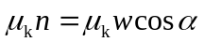 and the component of the weight down the skids is 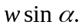 In this case, the angle is 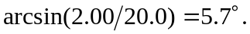 The ratio of the forces is 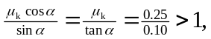 so the friction force holds the safe back, and another force is needed to move the safe down the skids.
b) The difference between the downward component of gravity and the kinetic friction force is

